Day 9
Task 1:
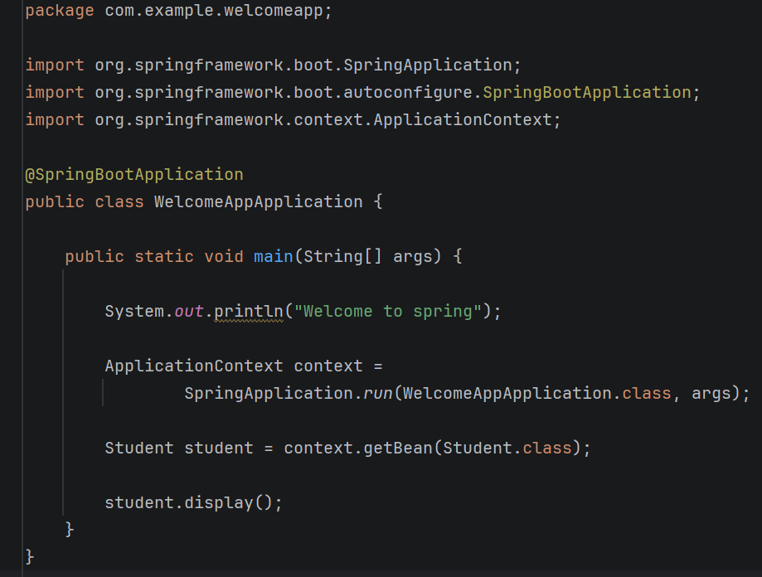
Task 2:
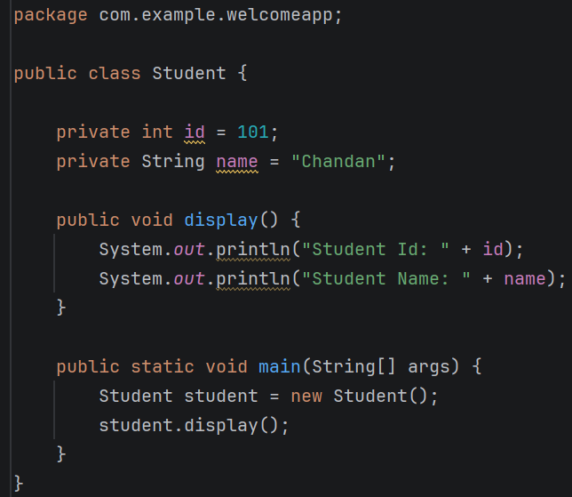
Task 4:
Application Context is the Spring Container. Its job is to Create Spring Beans, Manage Spring Beans, inject dependencies, provide beans whenever required. Think of it as a bean factory that stores and manages all Spring objects.
Syntax -
ApplicationContext context = SpringApplication.run(WelcomeAppApplication.class, args);
- ApplicationContext context
Creates a reference to the Spring Container
- SpringApplication.run(WelcomeAppApplication.class, args);
Starts the Spring Boot application and creates the Spring Container.

Task 5:
In Spring, we don't always need ApplicationContext, but it's important because it gives access to the Spring container and its managed beans.
- Get a spring bean
- Manage bean lifecycle
- Dependency injection
- Access any bean anywhere
Task 6:
- IoC (Inversion of Control)
Spring manages object creation and lifecycle instead of the programmer creating objects manually using new.
- Dependency Injection (DI)
Dependencies are injected automatically by Spring, reducing tight coupling between classes.
- Lightweight Framework
Spring is lightweight because it requires minimal resources and can be used selectively as needed.
- Bean Management
Spring creates, configures, and manages objects (beans) through the IoC container.
- Spring MVC
Provides a powerful framework for developing web applications using the Model-View-Controller design pattern.
- Exception Handling
Provides a consistent and easy way to handle exceptions across the application.

Task 7:
Spring Framework is used to develop Java applications faster, with less code, better maintainability, and easier testing. It handles many common tasks such as object creation, dependency management, database operations, security, and web development.
Advantages include –
- Light weight
- Dependency injection
- Loose coupling
- Easy testing
- POJO – Based development
- Faster development
Task 8:
Spring manages object creation and lifecycle instead of the programmer creating objects manually using new.
Task 9:
- Constructor injection - Dependencies are provided through the constructor.
- Setter injection - Dependencies are provided using setter methods.
- Field injection - Dependencies are injected directly into fields.
Task 10:
DI (Dependency injection) in spring is a feature where the Spring Container automatically provides the required objects (dependencies) to a class instead of the class creating them itself.
Task 11:
There are three types in DI they are
- Constructor injection
- Setter injection
- Field injection
Task 12:
Spring Application Configuration is the process of telling Spring. Which beans to create, how beans should be connected (dependencies), Application settings.
Task 13:
- XML configuration
- Java based configuration
- Annotation based configuration
Task 14:
Spring Application Configuration is needed to tell Spring which objects (beans) to create, how those objects should be connected, what settings the application should use, How Spring should manage the application components.
Task 15:
- XML configuration
Configuration is written in an XML file (beans.xml).
- Java based configuration
- Annotation based configuration.
Task 16:
Bean Scope determines whether Spring creates a single object or multiple objects of a bean.
Task 17:
Auto wiring means Spring automatically connects one bean with another bean.
Task 18:
- Field injection
- Setter injection
- Constructor injection
Task 19:
A normal Java object is created using the new keyword.
A Spring Bean is a Java object that is created, configured, and managed by the Spring IoC Container.
Task 20:
Both @Component and @Bean are used to create Spring Beans, but they are used in different ways.
- @Component is placed directly on a class.
- @Bean is placed on a method inside a configuration class.
Task 24:
- Auto Configuration
- Embedded Servers
- Starter Dependencies
- Minimal Configuration
- Production-Ready Features
- Rapid Application Development
- Spring Initializer Support
- Microservices Friendly
Task 25:
- Rapid Application Development
- Auto Configuration
- Embedded Server
- Reduced Boilerplate Code
- Starter Dependencies
- Easy Microservices Development
- Easy Database Integration
- Easy Testing
- Dependency Injection Support
- Easy Deployment

Task 26:
- Spring Boot Starters
- Auto Configuration
- Embedded Server
- Spring Application Class
- IoC Container
- Spring Data Support
Task 27:
Spring Boot is used over Spring because it simplifies application development by providing autoconfiguration, embedded Tomcat, starter dependencies, and minimal configuration, resulting in faster development and deployment.
Task 28:
- Application Startup
- Creation of IoC Container
- Component Scanning
- Bean Creation
- Dependency Injection
- Auto Configuration
- Embedded Server Initialization
- Dispatcher Servlet Initialization
- Request Mapping
- Application Ready
- Request Processing
- Response Generation
Task 29:
Starter dependencies are pre-configured dependency packages that simplify project setup.
Task 31:
server.port=9090
then your application will run on:
http://localhost:9090

